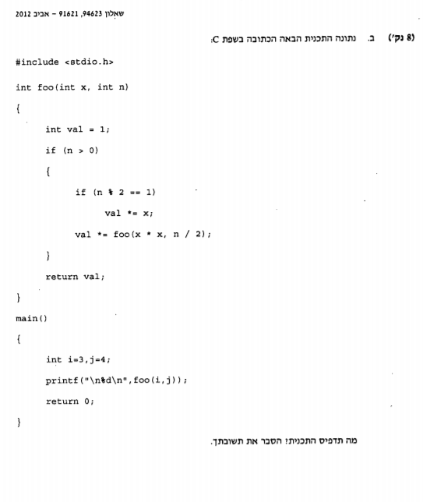

|  |  |  |  |  |  |  |  |
| --- | --- | --- | --- | --- | --- | --- | --- |
| foo | X | N | Val | val | Val | val | print |
|  | 3 | 4 | 1 |  |  |  |  |
|  | 9 | 2 |  | 1 |  |  |  |
|  | 81 | 1 |  |  | 1 |  |  |
|  |  |  |  |  | 81 |  |  |
|  | 6561 | 0 |  |  |  | 1 |  |
| 1 |  |  |  |  |  |  |  |
| 81 |  |  |  |  |  |  |  |
| 81 |  |  |  |  |  |  |  |
|  |  |  |  |  |  |  | 81 |